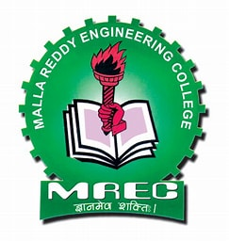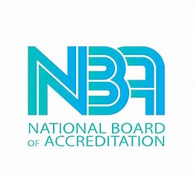 MALLA REDDY ENGINEERING 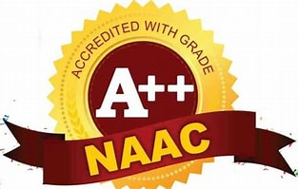
COLLEGE(AUTONOMOUS)
(An Autonomous Institution approved by UGC and Affiliated to
JNTU Hyderabad, Accredited by NAAC with ‘A++’ Grade,
Accredited by NBA, Maisammaguda, Dhulapally, (Post via Kompally),
Secunderabad-500100 ph: 6463434).

Name of the Lab: Automata and Compiler Design Lab -I/Network Security
and Cryptography Lab-1
Lab In-Charge : Mrs. D. Rabiya Begum / Mrs.V.Pranati
Lab Location : G-10

